EXPERIMENTS

11. Dataset: Geographic Data
City | Populatio  n | Avg.  Temperature | Elevatio  n
City  A | 500000 | 75 | 1000
City  B | 700000 | 68 | 800
City  C | 600000 | 80 | 1200

1. Create a map chart to visualize the distribution of cities on a geographic map. Label the map
elements.
2. Generate a scatter plot to explore the relationship between average temperature and population
size. Explain any insights.
3. Build a table to display the geographic data for each city. Label the table elements.
4. Develop a Tableau dashboard combining the map chart, scatter plot, and the table for interactive
exploration of geographic data.
1. Create a bar chart to visualize the quantity of each product in the inventory. Label the axes and title
the chart.
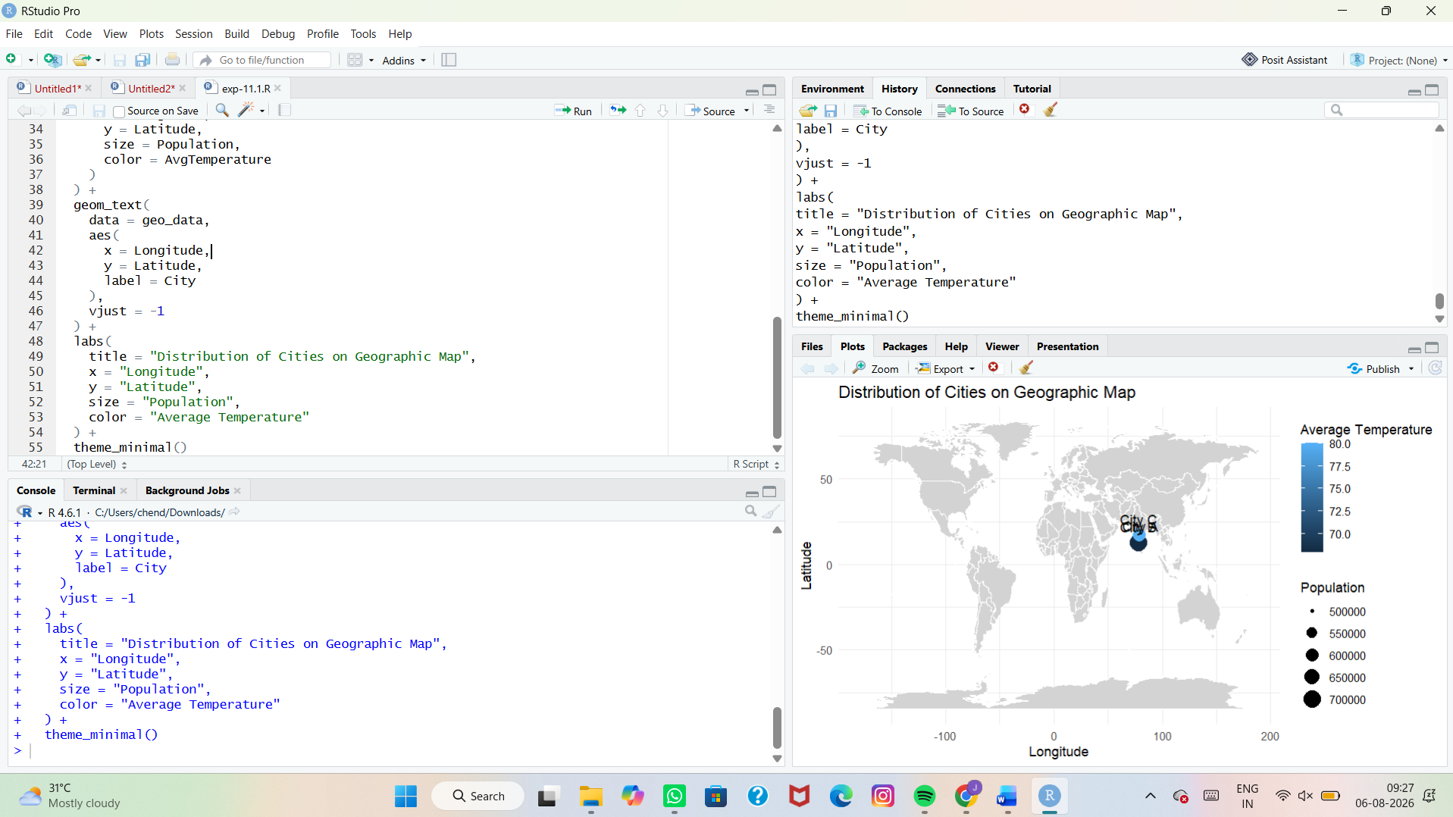
2. Generate a stacked bar chart to show the quantity of each product within different product
categories.
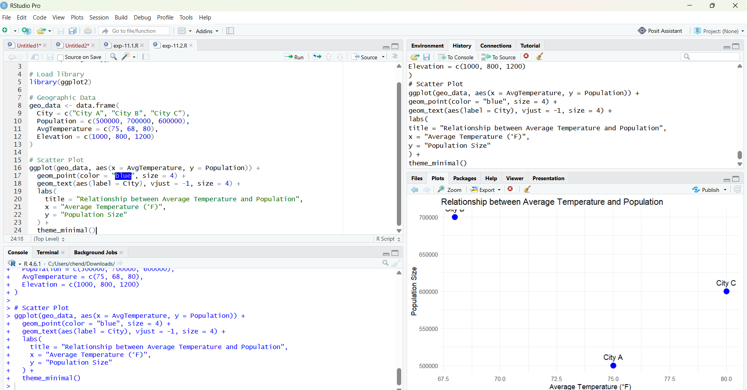
3. Build a scatter plot to explore the relationship between product price and quantity available. Explain
the findings.
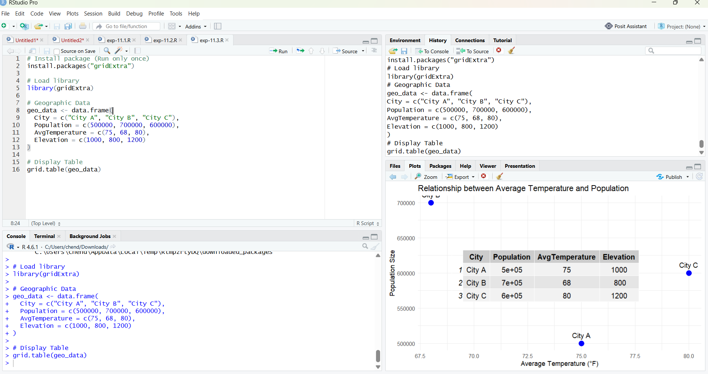

4. Develop a Tableau dashboard with the bar chart and stacked bar chart to allow users to interact
with the data.
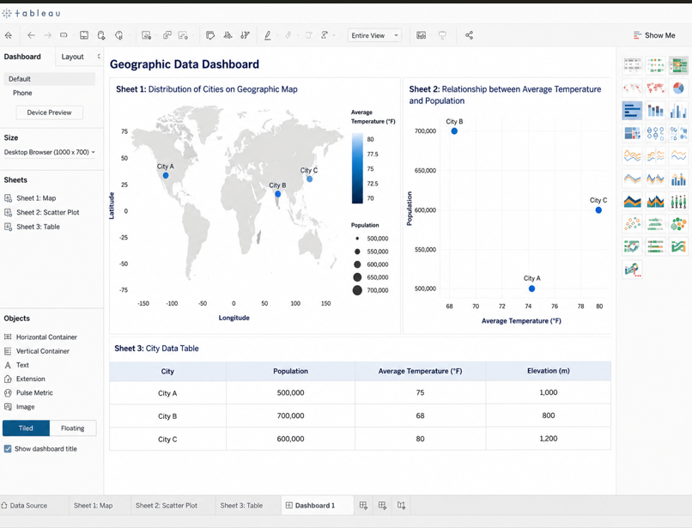
Geo tag photo:
